**TABLE OF CONTENTS**

|  |  |
| --- | --- |
| **Contents** | **Page No** |
| 1. Introduction |  |
| 2. Applications of monitoring Temperature & Humidity through DHT11 |  |
| 3. Applications of Things board |  |
| 4. Tools & Components |  |
| 5. Hardware setup & Working |  |
| 9. Code Implementation |  |
| 10. GUI Implementation |  |
| 11. References |  |
| 12. Conclusion |  |

**INTRODUCTION**

DHT11 is a low-cost digital sensor for sensing temperature and humidity.  This sensor can be easily interfaced with any micro-controller such as Arduino, Raspberry Pi etc… to measure humidity and temperature instantaneously.

DHT11 humidity and temperature sensor is available as a sensor and as a module. The difference between this sensor and module is the pull-up resistor and a power-on LED. DHT11 is a relative humidity sensor.  To measure the surrounding air this sensor uses thermistor and a capacitive humidity sensor.

**Working Principle of DHT11 Sensor :**

DHT11 sensor consists of a capacitive humidity sensing element and a thermistor for sensing temperature.  The humidity sensing [capacitor](https://www.elprocus.com/construction-of-capacitor-with-working/) has two electrodes with a moisture holding substrate as a dielectric between them. Change in the capacitance value occurs with the change in humidity levels. The IC measure, process this changed resistance values and change them into digital form.

For measuring temperature this sensor uses a Negative Temperature coefficient thermistor, which causes a decrease in its resistance value with increase in temperature. To get larger resistance value even for the smallest change in temperature, this sensor is usually made up of semiconductor ceramics or polymers.

The temperature range of DHT11 is from 0 to 50 degree Celsius with a 2-degree accuracy. Humidity range of this sensor is from 20 to 80% with 5% accuracy. The sampling rate of this sensor is 1Hz .i.e. it gives one reading for every second.  DHT11 is small in size with operating voltage from 3 to 5 volts. The maximum current used while measuring is 2.5mA.

**Working Principle of Raspberry pi 4 :**

Raspberry Pi is the name of a series of single-board computers made by the Raspberry Pi foundation, a UK charity that aims to educate people in computing and create easier access to computing education.

The Raspberry Pi launched in 2012, and there have been several iterations and variations released since then. The original Pi had a single-core 700MHz CPU and just 256MB RAM, and the latest model has a quad-core CPU clocking in at over 1.5GHz, and 4GB RAM. The price point for Raspberry Pi has always been under $100 (usually around $35 USD), most notably the Pi Zero, which costs just $5.

All over the world, people use the Raspberry Pi to learn programming skills, build hardware projects, do home automation, implement Kubernetes clusters and Edge computing, and even use them in industrial applications.

The Raspberry Pi is a very cheap computer that runs Linux, but it also provides a set of GPIO (general purpose input/output) pins, allowing you to control electronic components for physical computing and explore the Internet of Things (IoT).

**Applications of monitoring Temperature & Humidity through DHT11:**

This sensor is used in various applications such as measuring humidity and temperature values in heating, ventilation and air conditioning systems. Weather stations also use these sensors to predict weather conditions.  The humidity sensor is used as a preventive measure in homes where people are affected by humidity.  Offices, cars, museums, greenhouses and industries use this sensor for measuring humidity values and as a safety measure.

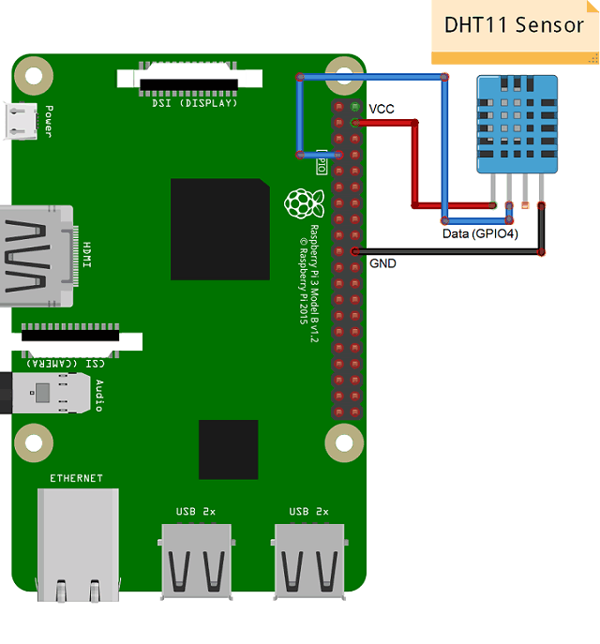It’s compact size and sampling rate made this sensor popular among hobbyists. Some of the sensors which can be used as an alternative to DHT11 sensor are DHT22, AM2302, and SHT71.

**Application of Thingsboard:**

Being robust, scalable and user friendly, ThingsBoard IoT platform supports various IoT use cases by providing flexible and powerful out-of-the-box features to cut down time to market of your connected products and smart solutions. The platform is device-agnostic, so you can feed and analyze telemetry data from any sensor, connected device or application. ThingsBoard comprehensive features and rich platform APIs allow you to save time and resources on routine IoT tasks and concentrate on specific features of your IoT solution.

Some of the industry use cases where ThingsBoard is being successfully utilized are listed below. Each use case is equipped with PoC dashboard and reference solution architecture.

**Dashboard:**

A dashboard is a visual display of all of your data. While it can be used in all kinds of different ways, its primary intention is to provide information at-a-glance, such as KPIs.

A dashboard usually sits on its own page and receives information from a linked database. In many cases it’s configurable, allowing you the ability to choose which data you want to see and whether you want to include charts or graphs to visualize the numbers.

**SMTP:**

* SMTP stands for Simple Mail Transfer Protocol. SMTP is a set of communication guidelines that allow software to transmit an electronic mail over the internet is called **Simple Mail Transfer Protocol**. It is a program used for sending messages to other computer users based on e-mail addresses. It provides a mail exchange between users on the same or different computers, and it also supports:
  + It can send a single message to one or more recipients.
  + Sending message can include text, voice, video or graphics.
  + It can also send the messages on networks outside the internet.
* The main purpose of SMTP is used to set up communication rules between servers. The servers have a way of identifying themselves and announcing what kind of communication they are trying to perform. They also have a way of handling the errors such as incorrect email address. For example, if the recipient address is wrong, then receiving server reply with an error message of some kind.

**Devices:**

Cloud. Platform as a service. Professional Edition. Advanced IoT platform. Community Edition. Open source platform.

Edge computing. IoT Gateway. Connect legacy protocols. License Server. Billing solution.

Trendz Analytics. Data analytics and Prediction. Mobile Application. IoT mobile product. PE Mobile Application.

**MQTT:**

MQTT (MQ Telemetry Transport) is a lightweight open messaging t provides resource-constrained network clients with a simple way to distribute telemetr information in low-bandwidth environments. The protocol, which employs a publish/subscribe communication pattern, is used for machine-to-machine (M2M) communication.

Created as a low-overhead protocol to accommodate bandwidth and CPU limitations, MQTT was designed to run in an embedded environment where it could provide a reliable, effective path for communication. Suitable for connecting devices with a small code footprint, MQTT is a good choice for wireless networks that experience varying levels of latency due to occasional bandwidth constraints or unreliable connections. The protocol has applications in industries ranging from automotive to energy to telecommunications.

**Rule-Chain:**

Rule Chains Administration UI page displays a table of configured tenant rule chains. You are able to do following operations:

* Import Or Create new Rule Chain.
* Export Rule Chain to JSON.
* Mark Rule Chain as Root Rule Chain.
* Delete the Rule Chain.

**GUI IMPLEMENTATION:**

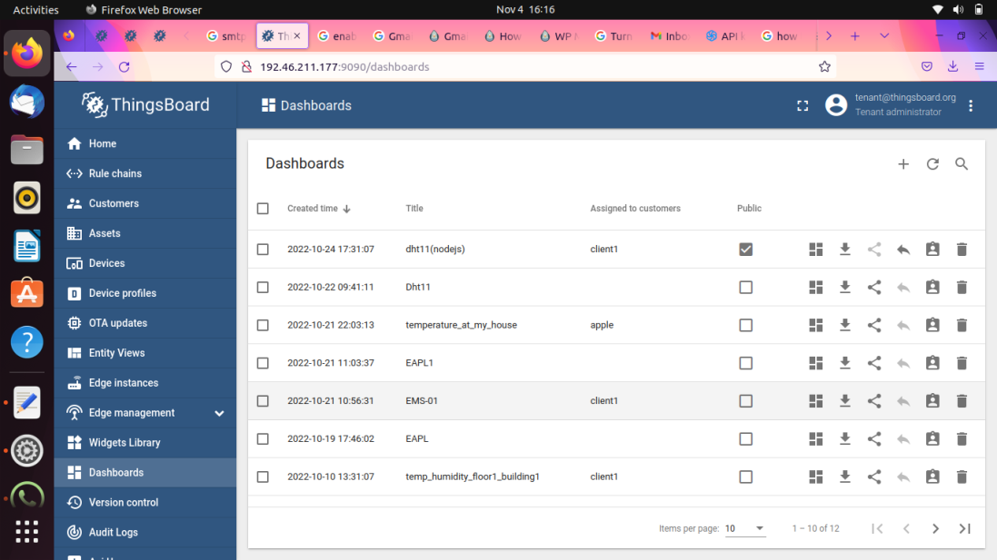

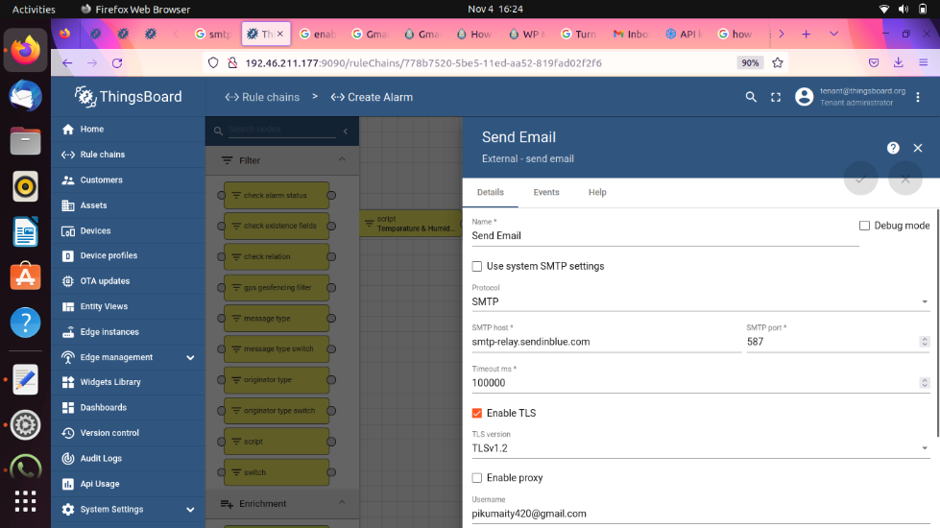

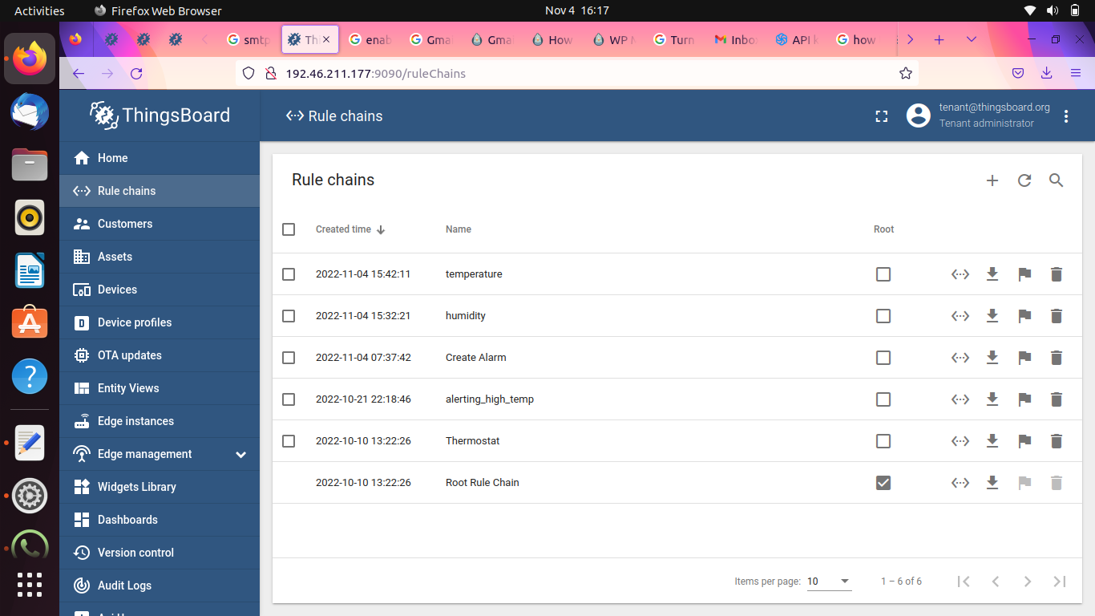

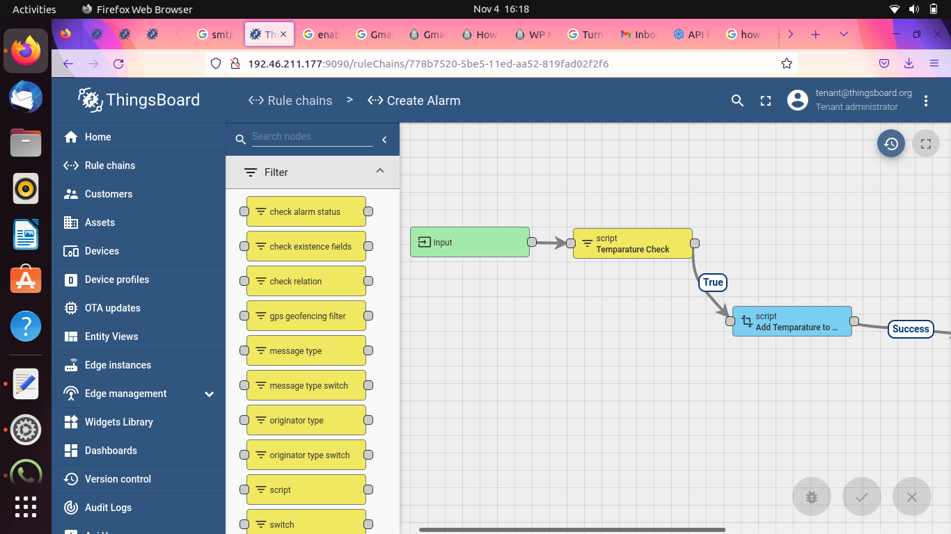

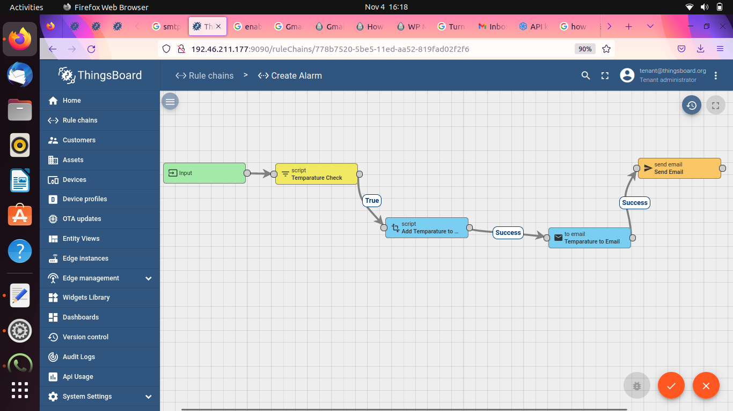

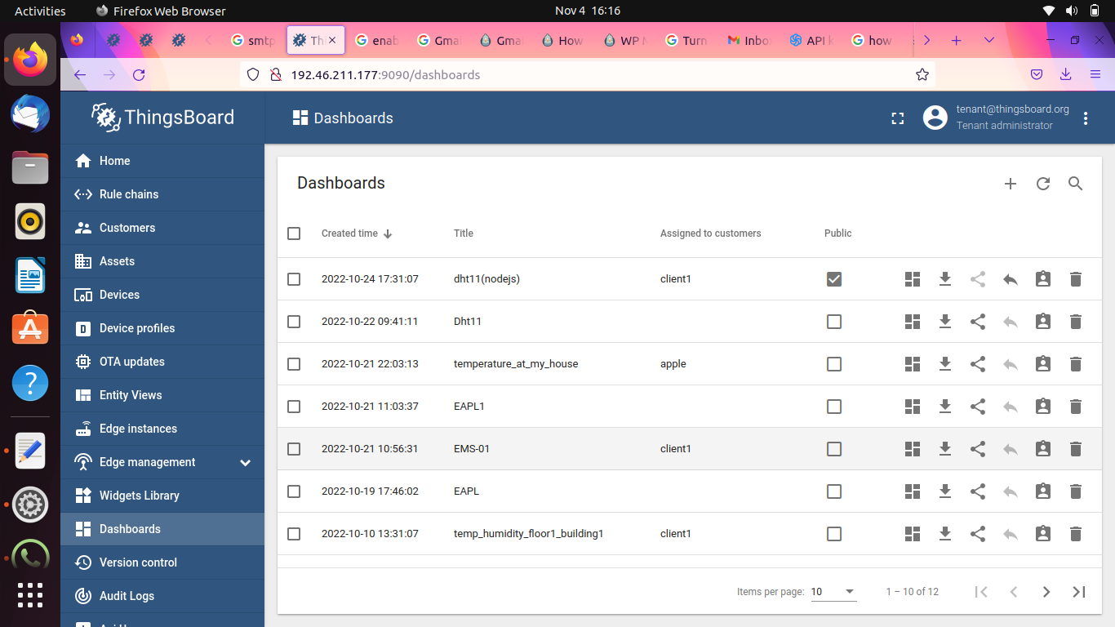

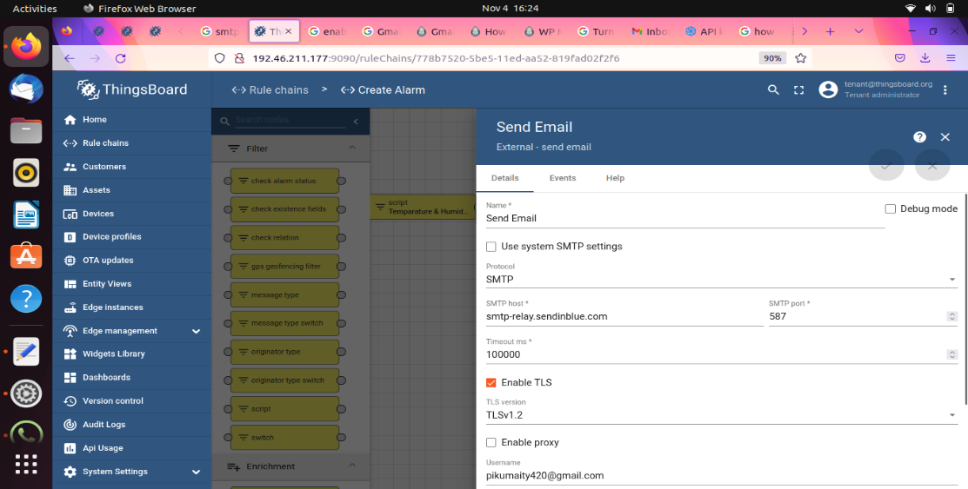

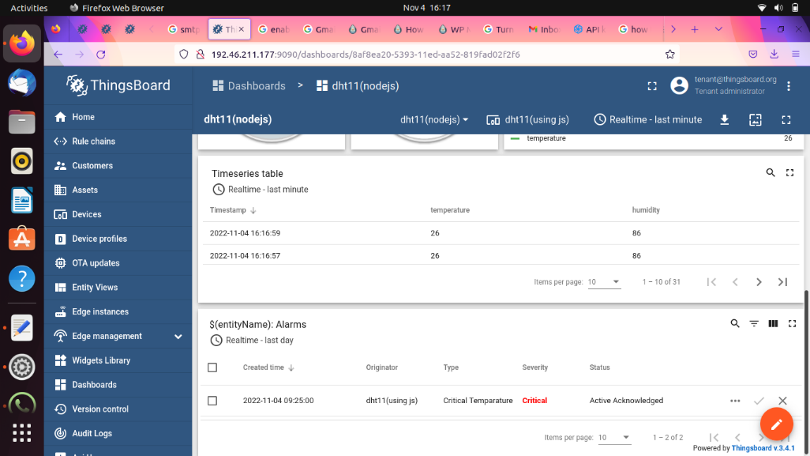



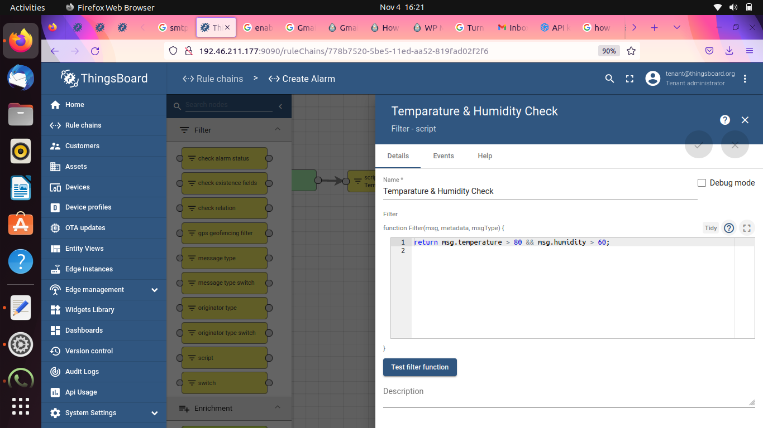

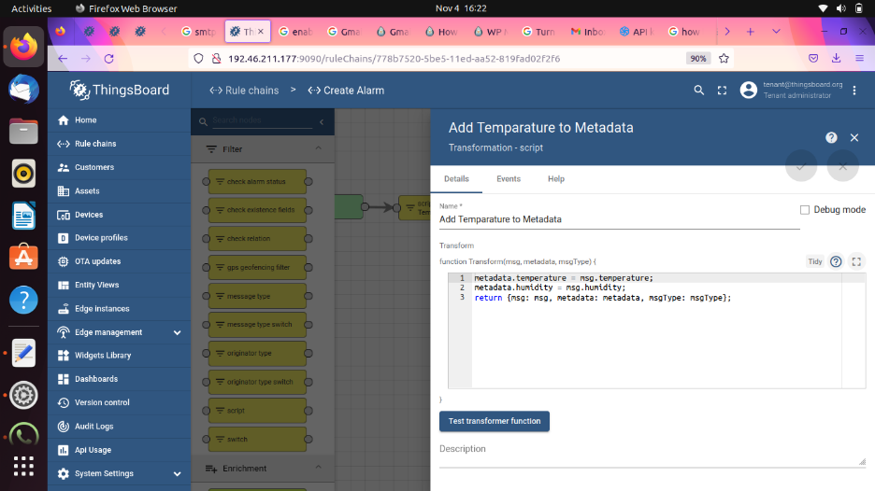

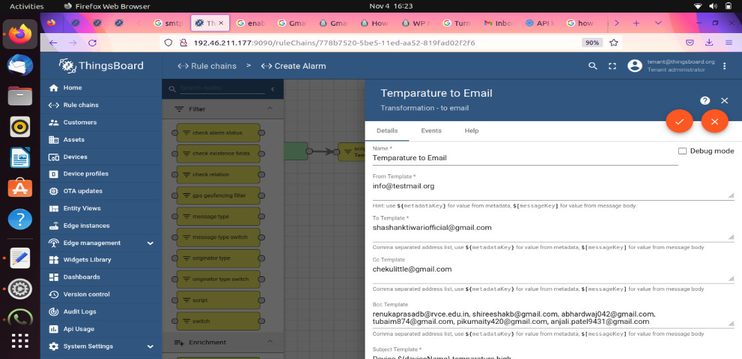

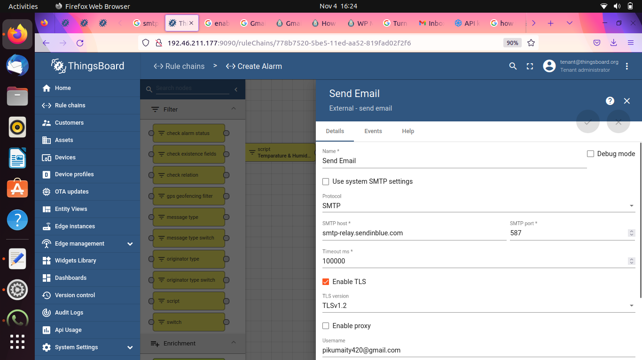

**Conclusion:**

Temperature & Humidity sensors template represents a generic monitoring solution suitable for multiple applications. With this template you get an interactive dashboard with ability to manage sensors and user-friendly alarms configuration.

By using DHT11 in Things board we have generated humidity and temperature in dashboard & based on certain conditions we have generated alarm in things board and by exceeding temperature and humidity we have generated mail in specific mail id.

**References:**

1. [**https://thingsboard.io/docs/paas/solution-templates/temperature-humidity-sensors/**](https://thingsboard.io/docs/paas/solution-templates/temperature-humidity-sensors/)
2. [**https://thingsboard.io/docs/paas/guides/**](https://thingsboard.io/docs/paas/guides/)